McLaine Week Visiting Artist presents:
GOOGLE ME!
February 1; Home Room at 8.30 pm
Ms. Stanescu will read from “Google Me!” her latest collection of poetry dedicated to the immigrant experience, intercultural communication and the Internet.

Often we express our feelings through the arts. Come and join us to hear Romanian poetry and see an Eastern European performance by I.House resident members.

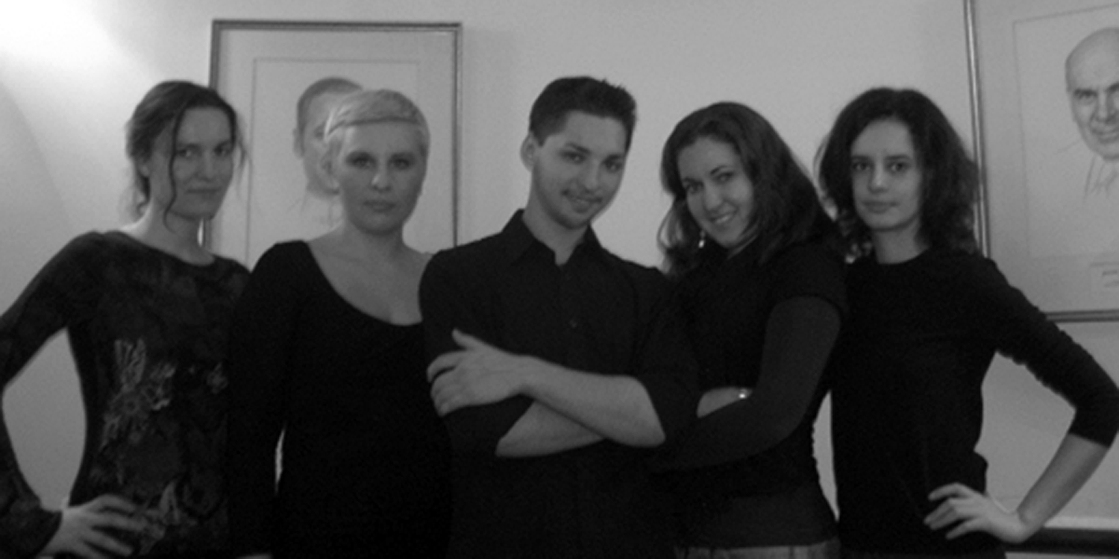
Saviana Stanescu
The evening will be completed with the presence of our beloved Eastern and Central European region residents: Maja Petric (Croatia), Ina Iankulova (Bulgaria), Maria Mandova (Bulgaria), Lena Norakidze (Kazakhstan &Georgia) and Paul Tarussov (Russia). They will join Ms Stanescu in reading “The letters of a barbarian woman”, one of the wonderful poems from “Google Me!”

International House is pleased to welcome back recent alumna (2004), Saviana Stanescu as a visiting artist during McLaine Week, the Eastern and Central European Leadership Program. Ms. Stanescu is a prominent Romanian poet, art critic and play writer.

Ina, Maja, Paul, Lena and Maria

A reception will follow the event.
If you have any questions/comments please feel free to contact Dora at x5421 or via e-mail at comandora1@yahoo.com

